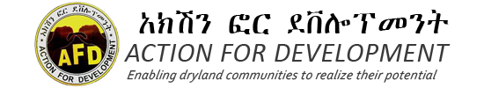
Action For Development
Communication /Guideline



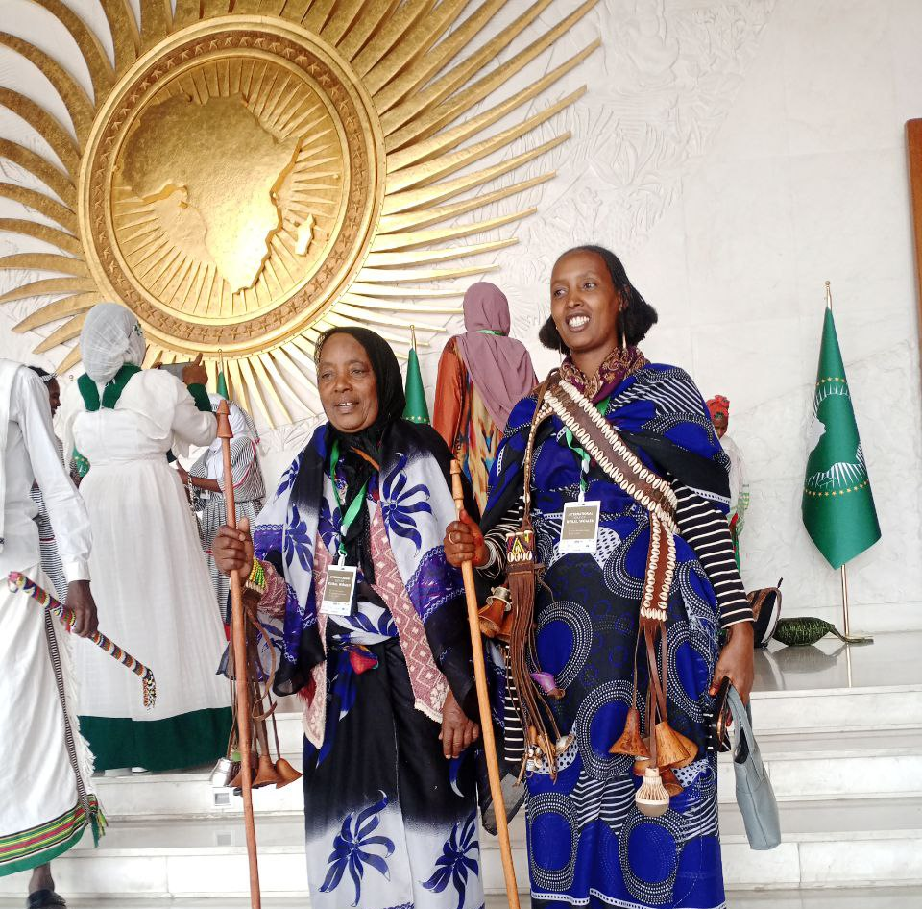

CommunicationStrategy/Guideline

June/2022

Contents
Acronyms 2
1. General background 3
2. Objectives of the Communication Strategy /Guideline 5
2.1 Overall Objective 5
2.2 Specific Objectives 5
3. Definition of applicable terms 5
4. AFD’s Principles of Communication………………………………………………………………….7
5. Strategic Approach: 8
6. Target Groups of Communication 8
7. Key messages and communication channels 10
7.1 Key messages: 10
7.2 Communication channels 11
8. Disclosure of confidential information 11
9. Monitoring and learning processes 12
10. Implementation roadmap………………………………………………………………….12

Annex
Annex 1 Type and nature of information to be shared
Annex II Summary of Information Disclosure

Acronyms
AFD Action For Development
CCA Climate Change Adaptation
CHS Core Humanitarian Standard
CSO Civil Society Organisations
DRM Disaster Risk Management
GA General Assembly
LD Line Department (GovernmentSector Office)
NGO Non GovernmentalOrganization
INGOs International Non-Government Organizations
MEAL Monitoring, Evaluation, Learning and Accountability
WASH Water, Sanitation and Hygiene
MOU…… Memorandum of Understanding
ED ……. .Executive Director
FCO Field Coordination Office

General background
AFD is a local organization (NGO) that is registered with FDRE Authority for CSOs, with certificate number 150. It implements a program of drylands development in the peripheral parts of Ethiopia. The AFD program is generally aimed at the attainment of food and nutrition security, and sustainable livelihoods at the grassroot level. To realize its objectives AFD implements programs in such thematic areas as building resilient livelihoods, WASH & other basic services, natural resource conservation and development, DRM and social protection, and the enhancement of civic engagement in processes of social transformation. AFD works in partnership with all people and organizations of good will.

  - AFD’s Profile
Vision
AFD envisions empowered, resilient, and thriving Ethiopian citizens leading a dignified life in an enabling and sustainable environment.
Mission
At AFD, we are a dynamic organization dedicated to the empowerment of pastoralists, agro-pastoralists, and other vulnerable communities across rural and semi-urban Ethiopia. Through strong partnerships with local communities and development actors, we enhance self-development initiatives by implementing principled humanitarian actions and integrated programs that foster climate-resilient livelihoods, WASH & other basic services, and citizen responsive governance. In these initiatives, we integrate such imperatives as gender equality, climate action, youth empowerment, capacity development, and continuous learning, ensuring that every individual has the opportunity to thrive in an inclusive and equitable environment.

Aims
The AFD programme, broadly, strives to contribute to the enhancement of:
- Food and nutrition security, and resilient livelihoods at the grassroots level
- Voice, space, and influence of deprived communities for the realization of citizen responsive governance

Core Values
People at the center
Integrity in all we do
Courage to innovate and learn
Passion for equity and justice
The power of partnership
Commitment to a sustainable future

- Thematic Areas
Climate-resilient livelihoods
WASH & other basic services
Humanitarian response
Citizen responsive governance

Operational Areas of AFD
The AFD program is primarily implemented in historically marginalized drylands where poverty prevails, capabilities are feeble, and people subsist in fragile environments. Currently, the AFD program is being implemented in 21 districts of the Bale, East Bale, and Borana zones of the Oromia region, and the South Omo, and Konso zones of SNNPR, known for their natural resource endowment and opportunities.
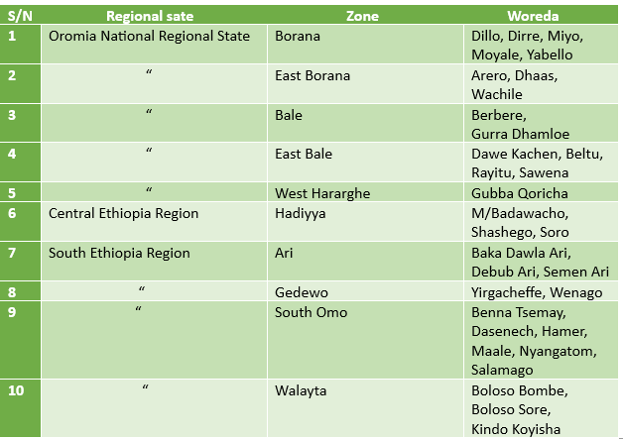
  - Purpose of This Strategic Guideline
Communication is vital for any organization; even more so, for organizations as AFD, which deliver their diverse programmes to different segments of society, in partnership with different stakeholders such as the community, sector offices, funding partners, private entities, and a multitude of knowledge and service providers.
Internally, communication fosters cohesion and the internalization of organizational policies, values, and norms. It, moreover, enhances clarity of purpose, and facilitates the realization of organizational goals. Externally, well designed and targeted communication efforts contribute to the portrayal of the correct image of the organization and its programme, help build constituency, diversify support base, and foster solidarity with other actors.Hence, AFD recognizes communication as an important and indispensable organizational function, deserving particular policies and procedures with which it is guided.

In line with this, this communication strategy/guideline, is prepared to among other things, highlight the norms governing communication with different stakeholders of AFD. It is, moreover, part of AFD’s identity. It sets out the type of information to be generated and shared, the target audience, and the main procedures of preparing and sharing up-to-date, and reliable information to the organization’s stakeholders and the wider public.

Objectives of the Communication Strategy/Guideline

Overall Objective
As a CSO functioning in the development, humanitarian, and wider civic realm, with a focus on historically marginalized drylands, it is imperative for AFD to engage in inclusive and transparent communication with a wide range of stakeholders. In line with this,the objective of this communication guideline is to realize AFD’s organizational aims, value, and mission by facilitating smooth information flow within and out of the organization. As we communicate effectively on different platforms, we can create awareness and/or shape attitudes, impart knowledge, promote organizational milestones, raise funds, and invite others to action.

Specific Objectives
Within the perspective identified above, AFD’s communication strategy/guideline is specifically aimed at the following:
- To enhance smooth communication and understanding with internal and external stakeholders;
- To promote the AFD brand and enhance its visibility among stakeholders;
- To promote AFD’s reputation as an accountable organization, whereby enhancing its ability to influence its stakeholders and the wider public;
- To provide reliable, timely, accessible and accurate information on the AFD program, and related deliverables;
- To enhance stakeholders’ participation and constituency building;
- To create opportunity for the generation and diversification of income;
- To provide opportunity for collecting feedback and drawing lesson, whereby enhancing organizational effectiveness.

Definition of applicable terms
The following statement could broadly define information for the purpose of this guideline
Information: - is data that has been verified to be accurate and timely, is specific and organized for a purpose, is presented within a context that gives it meaning and relevance, and that can lead to an increase in understanding and decrease in uncertainty.
Authorized Persons are: - The executive director of AFD and any staff specifically assigned in their area of competence. Also, authorized persons are those whose communication with staff members and external stakeholders falls within their approved job description.
Basic Organizational Information: - It can be any information about AFD, including its strategy, communication strategy, plan and budget, reports, procedural manuals, published research products, information on relationships with stakeholders, and others that the Board decides to be included as basic organizational information.
Confidential Organizational Information: - It is any information that has not been made publicly accessible by an authorized body. Due to their nature of confidentiality, private cases of employees, court cases that are not concluded, studies and assessments that are being synthesized and not finalized, issues under investigation, and other pending issues may not be disclosed.
External Communication is the dissemination of information to external stakeholders such as those stakeholders who serve either as sources or disseminators of information, legislators or policy authors, implementers, vulnerable groups, and the like. Among these, one can site the following:
  - Pastoralists and smallholder farmers
  - Policy makers and sector offices
  - Intergovernmental organizations
  - INGOs, NGOs, CSOs, and consortia of these
  - Research and academic institutions
  - Private sector entities with relevance to the AFD programme
  - Relevant influential individuals
  - Media
  - Community associations
  - Local authorities
  - International resource and project partners
  - Like minded organizations, movements and groups nationally and internationally

Internal Communication is the dissemination of information to internal stakeholders. Our internal audience includes individuals and entities regularly and closely engaged to promote the vision and steer the core business of AFD. They have a mixed role such as supporting or making decisions, implementing programmes, promoting organizational collaboration, and the like. Among these, one can site members of the AFD GA, Board, and Secretariate.
Media or Press Releases are communication products information such as news of events, policy dialogues, conference proceedings and communiques, policy positions, or any other related piece of information as decided by the Board to be worthy of sharing with the general public or a specific set of target audiences. The channels may include print media(newspapers, newsmagazines),broadcast news(radio and television), and the internet (online newspapers news blogs, etc.) as well as other social media platforms.

- AFD’s Principles of Communication
In order to make the best out of its communication efforts with both internal and external stakeholders, whereby contributing to the realization of its organizational objectives, AFD needs to adopt some principles which its communication is guided. These principles are outlined below:
- All information to be shared must be reviewed for accuracy, timeliness and relevance to the purpose it is intended to serve, and accessibility to the targeted audience
- All information to be shared must be reviewed for any risk it may carry to the reputation and safety of AFD, its broad stakeholders, its organs of governance, leadership and staff.
- Principles of upholding confidentiality, channels of communication, and signoff authorization shall not be misused to discourage an open flow of information or suppress efforts to uphold transparency and accountability. The Board (or, where appropriate, the General Assembly) may issue a guideline for whistleblowing when such is deemed helpful to help accountability.
- To the extent possible the generation, packaging and dissemination of all information must recognize, respect, be sensitive, and responsive to the needs of diverse cultures, languages, and the interests of deprived men and women, and other vulnerable groups.
- All AFD communication must be consistent in style and message to build its brand and stakeholder trust.
- The consent of vulnerable groups or programme participants should be sought before taking their picture, or use information obtained from them as case stories or other communication material.
- The communication requirements, brands, and standards of our stakeholders such as funding partners will always be respected.
- Feedback on communication to be disseminated should be regularly sought, in order to enhance learning and accountability.

Strategic Approach:
This communication strategy will use the following four interlinked key approaches in order to meet the intended objectives:
- Building the capacities of key internal and external stakeholders on effective engagement and promotion of the AFD vision and brand.
- Establishing linkages with relevant platforms, networks and institutions to ensure shared learning and collective voicing.
- Investing in, and making use of the evolving information and communication technology to enhance access to information, better external outreach, expand virtual presence and better internal interaction
- Resource mobilization to benefit from communication and technical expertise, platform sharing, finance.
- Being mindful of using communication as a means of inspiring shared values, clarifying purpose, and achievement of organizational objectives.

Target Groups of Communication

AFD implements its development and humanitarian interventions in an interactive environment involving multiple stakeholders. We communicate with these stakeholders, among other things, for the purpose of imparting organizational values and image. AFD’s target audiences include such groups and individuals as the community with whom the organization partners to complement its initiatives; the sector offices found at various level that give various administrative and technical support in their mandated areas; the funding partners that provide resource and other support to enable AFD deliver its programme;AFD’s organs of governance that guide and oversee organizational policy and operational issues; the employees responsible for the day to day activity;like-minded CSOs, and the wider public. These have variable influence overthe potential of AFD to deliver its mission and realize its objectives. Hence, maintaining effective communication with them will go a long way in ensuring the success of AFD.

The major internal and external communication audiences of AFD are provided in the table below:
S/N | Category | Users | Remark
I | AFD’s organs of Governance | Members of the General Assembly
I | AFD’s organs of Governance | General Assembly working groups
I | AFD’s organs of Governance | Board of Directors
II | Secretariat | Staff at all levels
2.1 | Sex disaggregated | Male staff
2.1 | Sex disaggregated | Female staff
2.2 | By work unit/location | Project Coordination Offices
2.2 | By work unit/location | Field Coordination Offices
2.2 | By work unit/location | Head Office
2.3 | Based on profile/responsibility | Executive Director
2.3 | Based on profile/responsibility | Members of Senior Management
2.3 | Based on profile/responsibility | Program and Project Officers
2.3 | Based on profile/responsibility | Grassroots programme staff
2.3 | Based on profile/responsibility | Administrative support staff
2.3 | Based on profile/responsibility | Auxiliarystaff such as guards and drivers with no proper office space
III | Partners | Funding partners/Donors and back donors
III | Partners | NGO Partners with whom AFD implements joint projects/members of consortium
III | Partners | Like minded NGOs/CSOs
III | Partners | CSO networks ofwhich AFD is a member
III | Partners | Policy makers and legislators
III | Partners | Project signatory LDs
III | Partners | Local authorities
III | Partners | Community programme participants and other local stakeholders
III | Partners | Community beyond the project area
III | Partners | Research and academic institutions
III | Partners | Media
III | Partners | Local and international resource organizations and service providers
III | Partners | Private sector actors
III | Partners | Influential individuals
III | Partners | General public

Key messages and communication channels
Depending on the purpose of communication and the specific needs of the audience, different types of communication/information will be conveyed using appropriate channels or instruments. Highlights are provided below:

Key messages:
Consistent, relevant and clear message is at the core of an effective communication strategy. Our messages are, among other things, based on the following:
- AFD’s vision and intervention strategies, key activities and milestones, as well as policies and instruments of organizational governance and operation.
- Changes in the lives of communities because of AFD’s intervention.
- Observed injustices, and their impact on the lives of the vulnerable groups.
- Best practices from our work or that of others.
- News and events of significance
- Perspectives and feedback of programme participants
Details are provided in the annex.

7.2 Communication channels
The most suitable communication tools need to be identified to effectively meet the needs of each target group. AFD employs various means of communications that offer opportunities for it to convey its messages to a wider audience.
- On-line: website updates,
- Print media: brochures, posters, magazine, flyers, picture documentation, banners, reports
- Social media: face book, twitter and you tube
- Telephoning
- Audio-visual: audio/video broadcast or documentation, documentary film,
- Meetings: larger public meetings, community leaders’ meetings, meeting with affected people.
- Billboards at village level and other public places.
- High-Tech; e-mail alerts
- High-Touch; communication which takes place in person with the actors.

Disclosure of confidential information
The organizational value of transparency, and the commitment to providing timely, accurate, and complete disclosure of AFD’s basic organizational information notwithstanding, unauthorized disclosure of confidential information is strictly prohibited. These include
- such things as private cases of employees,
- court cases that are not concluded,
- studies and assessments that are being synthesized and not finalized,
- issues under investigation and not finalized, etc.
Likewise, staff members or other internal stakeholders should refrain from making public statements on behalf of the organization, its various stakeholders or its explicit or implied positions on various policy or programmatic issues. Such statements may include personal opinions, part or whole of AFD’s official positions, and may take the form of quotes given to media, contribution to blogs, published articles, oral communication, etc.

Monitoring and learning processes
Communication is at the heart of AFD’s endeavor, and its effectiveness or lack thereof will significantly impact on its operation, credibility, image or its long-term identity. While communication carries the potential to shape and make lasting relationships, it at the same time harbors the risk of breaking ties or brings harm both to the organization and its closest stakeholders. It, is therefore, critical to continually scan the operating environment for potential risks that are likely to evolve due to the content, audience, timing or channel of both internal and external communications.
In consideration of the above, and the need for continuous improvement, this communication strategy/guideline will be accompanied by an inbuilt process of tracking delivery that contributes toorganizational learning. This will serve to monitor the effectiveness and relevance of its implementation, ensures accountability and, identifies and manages risks in time.

- Implementation roadmap
This communication strategy/guideline will be operationalized in conjunction with the other relevant manuals ad guidelines of AFD. All internal stakeholders are encouraged to comply with the agreed communications strategy/guideline, and enhance open, simple and quick exchange of information that supports and upholds our shared vision, values and guiding principles. Needless to mention that this doesn’t preclude credible grievances or whistleblowing, when found necessary and appropriate.

As the focal point for the function, AFD’s Communications Officer will develop periodic communication plan, and guide its implementation. Resources permitting, AFD will allocate annual budget necessary for the implementation of the plan. The MEAL advisor will have a complementary role in tracking the implementation of the plan, and informing processes of learning, improvement, and accountability. On the basis of this, the necessary periodic amendment to the strategy/guideline will be made upon the authorization of the Board.

Annex 1Type and nature of information to be shared

S/N | Category of information | Type of information | Responsible body to disclose | Location of information | Time/duration/frequency of delivery | Means/media of communication
I | Category on the basis of Governance | Organizational manuals/ guides, | Executive Director or, HR and Admin Manager. | Secretariat files;  Resource center; organizational website. | Upon request; during induction for new staff | Face to face; electronic media.
I | Category on the basis of Governance | MOA, MOU | Executive Director or, heads of dep. Managers | Secretariat files. | Upon request, during induction for new staff | Face to face; electronic media.
I | Category on the basis of Governance | Brochures, Leaflets | Communication Officer; other staff; field project offices | AFD offices at various levels; AFD website | During visits/events, duringinduction for new staff; uponrequests; AFD web site. | Hand delivery of hard and soft copies; websites and other social media plate forms.
I | Category on the basis of Governance | Program operation /technical guidelines/ | Heads of department; field/ project office coordinators at various levels, other responsible staff. | Secretariat files; resource center;AFD web site | Upon request; during induction for new staff | Hand delivery of hard and. softcopies;
I | Category on the basis of Governance | Changes made in guides and manuals | Head office departments; other responsible staff | Secretariat files.; AFD web site | In 15 working days after endorsement, | Hand delivery of hard and. soft copies / Oral/ written communication.
I | Category on the basis of Governance | Relevant Government policy, legislation, guidelines, circulars | AFD head office and FCOs, | Secretariat files;  Resource center. Field/Project coordination office. | For new ones, within 30 days of issuance; during induction for new staff ,&Upon request | Hand delivery of hard and. soft copies / Oral/ written communication.
I | Category on the basis of Governance | Major decisions made by the governance body and senior management | ED | AFD &FCO Archive | In two weeks time after decision | Hard copy
I | Category on the basis of Governance | Contact details of key personnel in each office | AFD HR and Admin manager and FCOs. | Secretariat files, Field project office, website. | One week time after assignment for new positions and regular update for changes and up on request. | Oral written communication, notice board, social media plate form websites.
I | Category on the basis of Governance | Donor’s partnership agreements/principles, core values | AFD head office | Executive director/ heads of Department/ other responsible staff | In one week, time after receiving the document and up on request | Oral/ written communication; Hard copy either with covering letter or circulation slip
II | Category on the basis of Operation
2.1 | Plans | Strategic plan | Executive Director, MEAL Advisor, other responsible staff. | Secretariat files,departmental/FCO/PO | In one month, time after endorsement. During induction of new staff and upon request. | Hand delivery of hard and soft copies
2.1 | Plans | Annual physical plan & budget | AFD Head office for the organization, FCOs, project office for their respective offices | ED office, AFD web site, AFD Archive FCOs, project offices | In one month time after endorsement. | Hard and soft copy
2.1 | Plans | Quarterly plan and budget | AFD Head office for the organization ,FCOs, project office, work units and teams for their respective offices, work unit & team | ED office, AFD web site, AFD Archive FCOs, project offices | In one week time after endorsement. | Hard and soft copy
2.1 | Plans | Monthly plan | AFD Head office for the organization ,FCOs, project office, work units and teams for their respective offices, work unit & team | ED office, AFD head office, AFD Archive ,Departments, FCOs and work teams, project offices and employees | In two days after approval. | Hard and soft copy
2.1 | Plans | Technical notes | Program, infrastructure departments/units at head office and FCOs and project office) | ED office, AFD head office, AFD Archive ,Departments, FCOs and work teams, project offices and employees | One week after preparation | Soft and hard copy
2.1 | Plans | Weekly plans | Work units, teams and employees | Managers or heads of Work units/teams, and employees | Every Monday morning | Soft and hard copy
2.1 | Plans | Budget amendments | Administration and Finance Departments/units together with other units | Manager/Heads of admin and Finance | Week after revision | Soft and hard copy
2.1 | Plans | List of donors, back donor with the amount of funding and core thematic area or activity | ED, Partnership and Resource Mobilization Department at head office | ED, Manager Partnership and Resource Mobilization, Departments at head office, Archive, organization Web site, annual& quarterly reports, audit reports | Second week of each quarter | Soft and hard copy
2.2 | Project report | Project periodic reports
2.2 | Project report | Progress update |  | AFD & FCO Archive | As required | Soft and hard copy
2.2 | Project report | Quarterly | Respective work units at head office and FCO/project offices(PME for Governance body, Program for donors and P&RM for government) | AFD &FCO Archive | For AFD board in one month after end of the quarter, For AFD management, 21 days after end of the quarter, Government in 14 days after end of the quarter. Donor As per the respective agreement | Soft and hard copy
2.2 | Project report | Bi annual | Respective work units at head office and FCO/project offices(PME for Governance body, Program for donors | AFD &FCO Archive | Donor As per the respective agreement
2.2 | Project report | Annual | Respective work units at head office and FCO/project offices(PME for Governance body, Program for donors | AFD &FCO Archive | Donor As per the respective agreement
2.2 | Project report | Mid term | Program Department /unit for donors, P&RM for Government | AFD &FCO Archive | one month after the end of the mid term | Hard and soft copy
2.2 | Project report | Terminal | Program Department /unit for donors, P&RM for Government | AFD &FCO Archive | Within the last quarter of the project for Government & as per the agreement for donor | Hard and soft copy
2.2 | Project report | Study documents | ED & Responsible work unit | AFD &FCO Archive | In two weeks’ time after completion of the study report. | Hard and soft copy
2.3 | Project agreements | Project Documents and Agreements entered with Donors and amendments made | ED & Admin and Finance Department | AFD &FCO Archive | In one week, time after signing. | Hard copy
2.3 | Project agreements | Project Documents and Agreements entered with Government Signatory Bureaus amendments made | P&RM department and FCOs for Government | AFD &FCO Archive | In one week, time after signing. | Hard copy
2.3 | Project agreements | Agreements with community representatives and amendments | FCOs | AFD &FCO Archive | In one week, time after signing. | Hard copy
2.3 | Project agreements | Contract agreements with consultants and changes made | ED & Admin and Finance Department | AFD &FCO Archive | In one week time after signing. | Hard copy
2.3 | Project agreements | Contract agreements with contractors and changes made | ED & Admin and Finance Department &FCOs | AFD &FCO Archive | In one week time after signing. | Hard copy
2.4 | Events | Meetings conducted or to be conducted with major outcomes:
2.4 | Events | General Assembly, | ED. | AFD &FCO Archive, AFD web site | Two weeks before and after the meeting | AFD web site, hard copy of the minute
2.4 | Events | Board | ED | AFD &FCO Archive, AFD web site | Two weeks before and after the meeting | Hard copy of the minute
2.4 | Events | Management meetings | ED &FCO coordinators | AFD &FCO Archive, AFD web site | One week after the meeting | hard copy of the minutes
2.4 | Events | Thematic working group | Group chair | AFD &FCO Archive, AFD web site | two weeks after the meeting | hard copy of the minutes
2.4 | Events | Program review | Program Dep. | AFD &FCO Archive, AFD web site | 21 days after the event | hard copy of the minutes
2.4 | Events | staff retreat | Responsible committee | AFD &FCO Archive, AFD web site | One month before and after the event | hard copy of the proceeding
2.4 | Events | Trainings and workshops, | Responsible work unit | AFD &FCO Archive, AFD web site | Two weeks before & after the training | Hard& soft copy of the proceeding
2.4 | Events | Relevant events, Local, Regional, National and International level
2.4 | Events | Changes in staffing/ newcomers, separations, promotion, transfer, obtained/organized. | AFD Admin. & Finance Dep. & FCOs and project office | Organization’s Notice board | In two weeks’ time before and after | Hard copy & electronic message
2.4 | Events | training opportunities | AFD Admin. & Finance Dep. & FCOs and project office | Organization’s Notice board | Before one month | Hard copy with covering & electronic message
2.4 | Events | Changes in office set up: new office establishment, closure of offices, and change of office address. | ED office | Notice board, AFD web site | Before three weeks | Hard copy and electronic message
2.4 | Events | Visitors arrived | ED,P&RM Dep., FCOs or project office | Notice board, web site | before month for arrival announcement and after two weeks of the visit | Announcement through email, regular reports, bi annual or annual
2.4 | Events | Announcements (Vacancies, bids, others) | Admin and Finance Dep. & FCOs | Newspaper, Notice boards, electronic message, AFD web site | As required | Newspapers, Notice boards, electronic message, AFD web site
 |  | New arrivals, Books, journals, periodicals, newspapers, brochures and other promotional materials. | Communications officer; other responsible staff. | Resource center; FCOs achieves, | As received up on request | Hand delivery of hard & soft copies; oral, written communication, website. item received

Annex II Summary of information disclosure
Type and category of information |  | Stakeholders |  |  |  |  | Public
 |  | Community | Donor | Government | Staff | AFD Governance | Public
 | General
 | Organizational manuals/ guides,
 | MOA, MOU
 | Brochures, Leaflets, magazines and other promotional materials.
 | Employment letter, Job description, etc...
 | Program operation guidelines/e.g., on water, education, cooperative, PME,
 | Changes made in guides and manuals
 | Relevant Government policy, legislation, guidelines, circulars
 | New arrivals, Books, journals, periodicals, newspapers, etc
 | Contact details of key personnel in each office
 | Donor’s partnership agreements/principles, core values
 | Plans
 | Strategic plan
 | Annual physical plan & budget
 | Quarterly plan and budget
 | Monthly plan
 | Weekly plans
 | Budget amendments
 | List of donors, back donor with the amount of funding and core thematic area or activity
 | Progress report
 | Project periodic reports
 | Progress update
 | Quarterly reports
 | Annual
 | Terminal
 | Study documents
 | Major decisions made by the governance body and senior management
 | Case studies
 | Project agreements
 | Project Documents and Agreements entered with Donors and amendments made
 | Project Documents and Agreements entered with Government Signatory Bureaus and amendments made
 | Agreements with community representatives and amendments
 | Contract agreements with consultants and changes made
 | Contract agreements with contractors and changes made
Events/
Meetings conducted or to be conducted with major outcomes:,
 | General Assembly,
 | Board meetings
 | Management meetings
 | Thematic working group meetings
 | Program review meeting
 | staff retreat
 | Trainings and workshops,
 | Relevant events, Local, Regional, National and International level
 | Changes in staffing/ newcomers, separations, promotion, transfer, obtained/organized.
 | training opportunities
 | Changes in office set up: new office establishment, closure of offices, and change of office address.
 | Visitors arrived
 | Announcements (Vacancies, bids, others)

